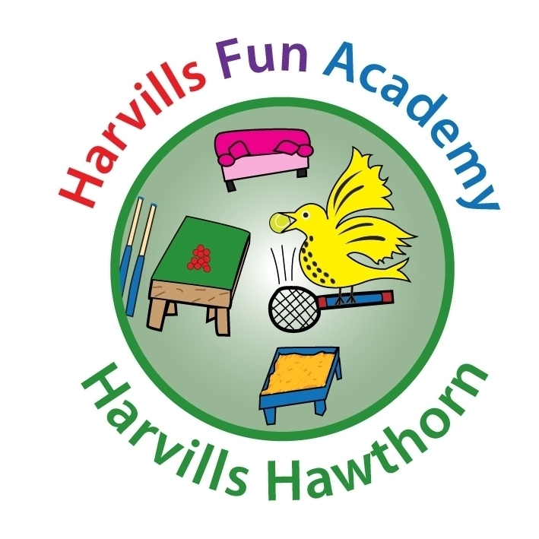
HARVILLS FUN ACADEMY
REGISTRATION FORM

Child’s details
Name |  | Class

Parent/Carer’s contact details
Name
Relationship

Contact number(s)
Email

Emergency contact details
Name
Contact number(s)

Medical and dietary information
Name of doctor
Doctor’s address
Doctor’s telephone number
Please list any medical conditions (e.g. asthma)
Please list any medical allergies (e.g. allergic to penicillin)
Please list any food allergies (e.g. dairy)

In signing this form, I declare the information to be true and accurate. I have read and accept the Terms and Conditions of Harvills Fun Academy.

Name: _________________________________________________________

Signed: ________________________________________________________

Date: ________________________________________________________

